Use-Case Realization Report
Take Lesson

Issue <1.0>
Revision History
Date | Issue | Description | Author
<dd/mmm/yy> | <x.x> | <details> | <name>

Table of Contents
1. Brief Description 4
2. Flow of Events 4
3. Interaction Diagrams 5
3.1 Collaboration Diagram for Take Lesson 5
4. Participating Objects 7
5. Class Diagrams 8
5.1 Class Diagram for Take Lesson 8
6. Derived Requirements 8

Use-Case Realization Report
Take Lesson

Brief Description

Flow of Events

Standard Flow
- User clicks the link of the lesson he/she is going to take.
- Lesson page will retrieve the lesson and section content to display.
- Meanwhile, lesson page will notify lesson controller the lesson is being taken.
- User finishes the lesson.
- Lesson controller will update the lesson module and the lesson progress as well.

Interaction Diagrams

Collaboration Diagram for Take Lesson
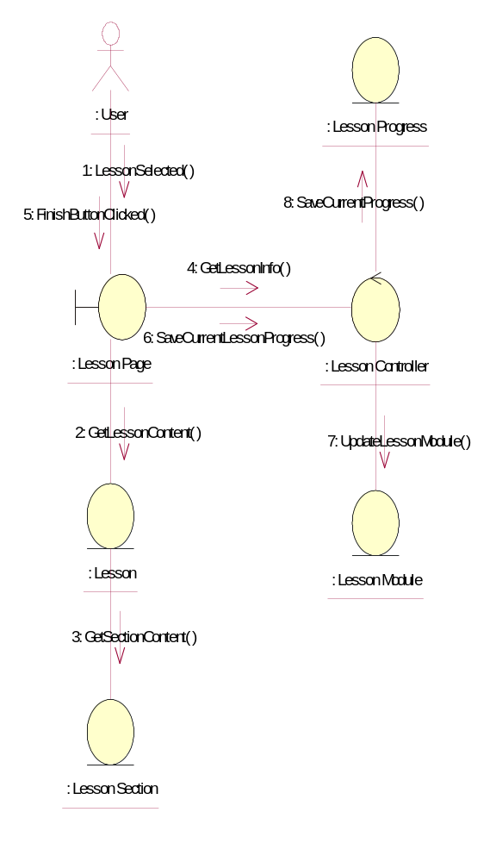

Participating Objects
: Lesson
This entity is the lesson object, it belongs to JMD.
: Lesson Controller
This is the controller to upload, add, delete and modify lessons.
: Lesson Module
This is the object containing the lesson info.
: Lesson Page
Lesson Page is the one from JMD, which in charge of creating lessons.
: Lesson Progress
This entity will record down the progress made by users on the lessons he/she involved in.
: Lesson Section
This entity is the Section object, it belongs to JMD.
: User
This is the end-user of the system

Class Diagrams

Class Diagram for Take Lesson
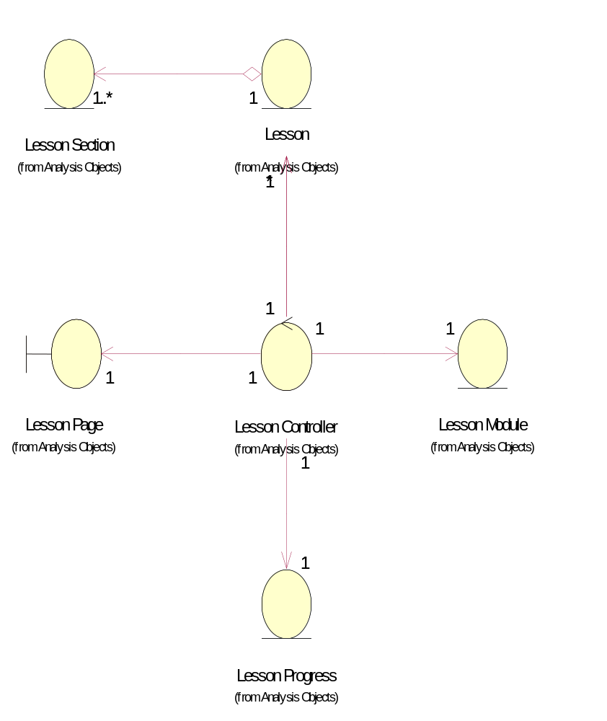

Derived Requirements
[enter the derived requirements here]

